Design Document for ???? project

Dream team
Zholdasbekov Aibek: %marks
Akhmetbekov Chingiz: %marks
Khamza Ayan: %marks
Kenzhegalin Serik: % marks

Version | Date | Author | Change
0.1 | 31/03/14 | DM | Initial Document
0.2 | 14/04/14 | DM | Completed sections 5.2
0.3 | 21/04/14 | DM | DD-3

Table of Contents
1 Introduction 3
1.1 Purpose 3
1.2 Scope 3
1.3 Definitions, Acronyms, Abbreviations 3
1.4 Design Goals 3
2 References 4
3 Decomposition Description 5
3.1 Module Decomposition 5
3.2 Concurrent Process 5
3.3 Data Decomposition 5
3.4 STATES 5
4 Dependency Description 6
4.1 Intermodule Dependencies 6
4.2 InterProcess Dependencies 6
4.3 Data Dependencies 6
5 Interface Description 7
5.1 Module Interface 7
5.2 Process Interface 7
6 Detailed Design 8
7 Design Rationale 9
7.1 Design Issues 9
7.2 <Issue 1> 9
7.3 <Issue 1> 9
8 Traceability 11

Introduction

Purpose
The purpose of this document is to explain the design and architecture of the pizzeria “Aszhan” web-site

Scope
This document covers system decomposition, interfaces, and dependencies, as well as design rationale.

Definitions, Acronyms, Abbreviations
Term | Description
Admin | Person who controls the web-site
Catering services | Catering is the business of providing food service at a remote site

Design Goals
- Reliability: the core process (major use-cases) must continually function consistently.
- Maintainability: Our code must be well organized with consistent syntax and relevant naming techniques.
- Extensibility: The application must facilitate easy extension of the “Aszhan” web-site and features to be added to the Java EE Code.
- Response Time: All Canvas pages must load in less than 30 seconds including library and database processing time.

References
[None]

Decomposition Description

Module Decomposition
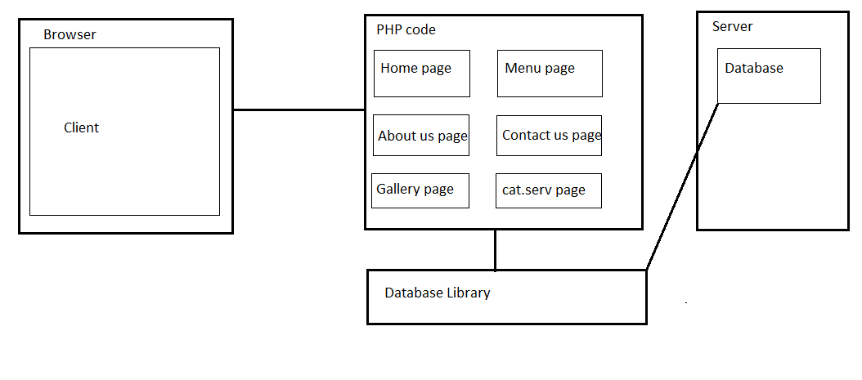
The project has client-server architecture, but there will be no client code. We turned down a repository architectural design (centralized around the database) and decided upon a layered (though not clear in the diagram) architecture allowing better interchangeability of our database. This design has three layers. The first contains the PHP Code. The second contains only the Libraries module. The third layer contains the Database, which provide services to the layer above through the database library.

PHP code is responsible for:

Showing GUI part of project

Providing Listeners

Listening client actions

Libraries description

Providing connection to MYSQL

Database description

Database (MYSQL) is used to store and retrieve all the data. Specifically, all the dishes the admin added will be stored here. On request, it will return all corresponding data.

Concurrent Process

Home page Description

Home page is the main page (index.php) in our web-site. It displays all the links to each page, specialties and news. News can be representing of new dishes. News will be added by admin by writing into database.

Menu page Description
Menu page displays all the dishes and its data. And it enables to order dishes. The client choose all dishes he wants and how many of them and then, he should write personal data (name, address, phone). After admin should phones to the client to confirm the order.

About us page description

About us page displays all the information (achievements, from where they are) about pizzeria “Aszhan”.

Contact page description

Contact page displays all the contact numbers, address of the organization.

Catering service page description

Catering service page displays all description about catering services

Gallery page description
Gallery page displays all the photos of the all

Gallery page description

Gallery page displays all photos (photos of organization, photos of dishes, photos of celebrations)

Catering service page description
Catering service page displays all the information about catering service. This is useful because most people don’t know what is catering service. To order catering service people should contact the system administrator.

Data Decomposition

“Dish” Database Table
id int auto_increment
name varchar(20)
description varchar(40)
price int
type_id int
photo varchar(50)
Primary key(id)

“Types” Database Table
type_id int auto_increment
type varchar(30)
photo varchar(50)
primary key(type_id)

“Clients” Database Table
id int auto_increment
name varchar(60)
surname varchar(60)
address varchar(50)
phone int(9)
primary_key(id)

“News” Database Table
id int auto_increment
Title varchar(40)
Content Text
Photo varchar(40)
Primary_key(id)

“Admin” Database Table
name varchar(30)
password varchar(40)

“Order” Database Table
order id auto_increment,
dish_id int,
client id int,
quantity int
primary key(order_id)
foreign key(client id ) references Clients(id)
foreign key(dish_id) references Clients(id)

STATES

<State/System 1 > Description

<State/System 2> Description

Dependency Description

Intermodule Dependencies

InterProcess Dependencies

Data Dependencies

Interface Description

Module Interface

<Module 1> Interface

<Module 2> Interface

Process Interface

JSP Process
Description: JSP shows all graphical interface of the system.

Process is created when someone makes requests for this site.

Process is terminated when he close the inset from browser.

Order Process
Description: When user need to order pizza at home

Process is created when order button pushed

Process is terminated after admin read this notification.

Database Listener Process

Process is created when we need to make change in database (add, edit, remove) or to retrieve data.

Process is terminated when jsp process terminated.

Detailed Design

NOT REQUIRED <Java Docs to be used instead>

Design Rationale

Design Issues

<Issue 1>

Description

Factors affecting Issue

Alternatives and their pros and cons

Resolution of Issue

<Issue 1>

Description

Factors affecting Issue

Alternatives and their pros and cons

Resolution of Issue

Traceability

No | Use Case/ Non-functional Description | Subsystem/Module/classes that handles it
1
2

FEEL FREE TO ADD APPENDICES AS NEEDED. UPDATE TOC BEFORE SUBMITTING

